**CSC-104L Database Systems Project Report**

**Library Management System**



**Submitted by:**

2023-CS-630 Samar Noor

**Submitted to:**

Prof. Usman Ghani

Dated: 10-May-2024

**Department of Computer Science**

**University of Engineering and Technology Lahore, New Campus**

**LIBRARY MANAGEMENT SYSTEM**

1. **Introduction:**

The Library Management System (LMS) project was initiated to streamline and automate the processes involved in managing a library. The motivation behind this project stems from the need to efficiently handle library operations, including Authorization feature, book issuance, return, and user management. By implementing an LMS, the aim was to improve the overall efficiency, accuracy, and accessibility of library services.

1. **Objectives:**

* Objective 1: Develop a user-friendly interface for Admin to manage Book Inventory, Register/Unregister Users, having a smooth control over the system with error handling.
* Objective 2: Robust systems are designed to gracefully handle unexpected errors, exceptions, or inputs without crashing or compromising the integrity of the system.
* Objective 3: To diligently work on front-end development, meticulously focusing on every color and size detail to achieve a visually polished and harmonious user interface.

1. **System Architecture:**

* Model (MS SQL Database): Represents the backend database, managing data storage and retrieval for entities like books, users, and transactions.
* Controller (C# with ASP.NET MVC 8.0): Acts as the intermediary between the frontend and backend, handling user requests, processing data from the Model, and rendering appropriate responses.
* View (Frontend Components): Developed using C# within ASP.NET MVC 8.0, responsible for presenting data to users in an interactive and visually appealing manner and interacting with the Controller to handle user input and trigger action.

**Functionalities:**

* Book Management:

1. Add, edit, and delete books.
2. Track details: title, author, ISBN, genre, availability.
3. Assign unique identifiers and barcodes.

* Book Management:

1. Register and manage members.
2. Maintain user info and borrowing system.
3. Enable authentication and authorization.

* Borrowing and Returning:

1. Facilitate book borrowing and returning.
2. Manage due dates, renewals, fines.
3. Update availability status.

* Admin Dashboard:

1. Monitor library activities and performance.
2. View real-time statistics.
3. **Design and Implementation:**

4.1 Design Phase:

Basically, we had three tables (User, Books, Borrower).

* Books table has a unique ISBN number (Guide), title, author, a short description, Genre, Borrower and Availability status.
* User table has its Id, username, password, email.
* Borrower table has Unique, Name, Email, Borrowed Book, and a check that if it is renting a book right now.
* Penalty table holds fine based on issue and return date.
* Borrow history table saves record of all book transactions.
* Other than this we have weak entity types that are dependent on books table for their existence (same attributes as Book).

1. Available Books.
2. Borrowed Books.

Relationships and extra attributes are shown in ERD.

4.2 User Interface Design:

Let’s have a look on User Interface.

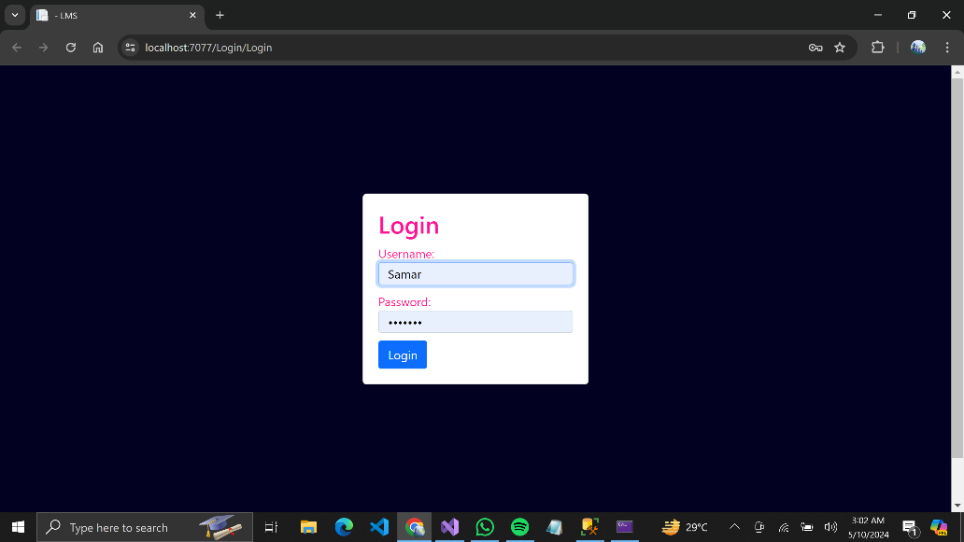

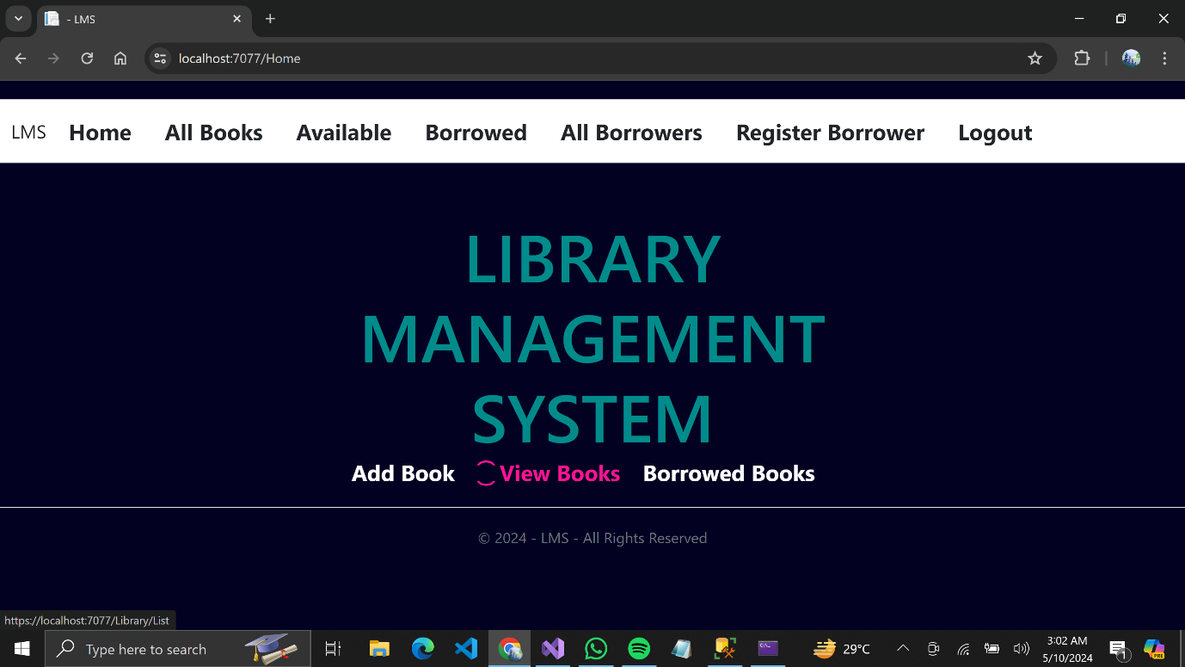

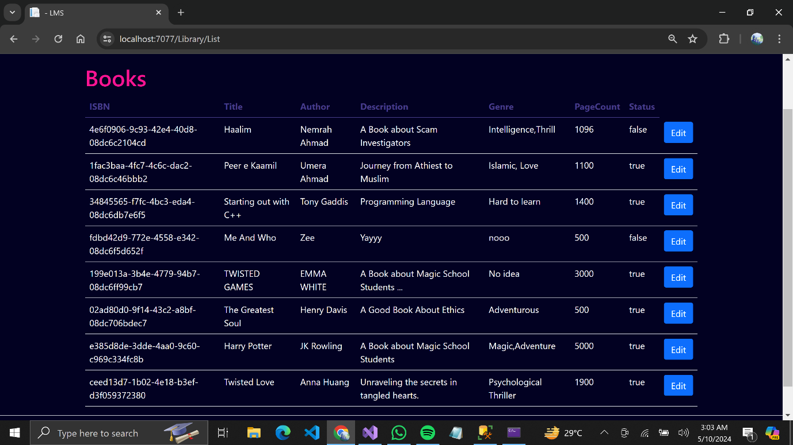

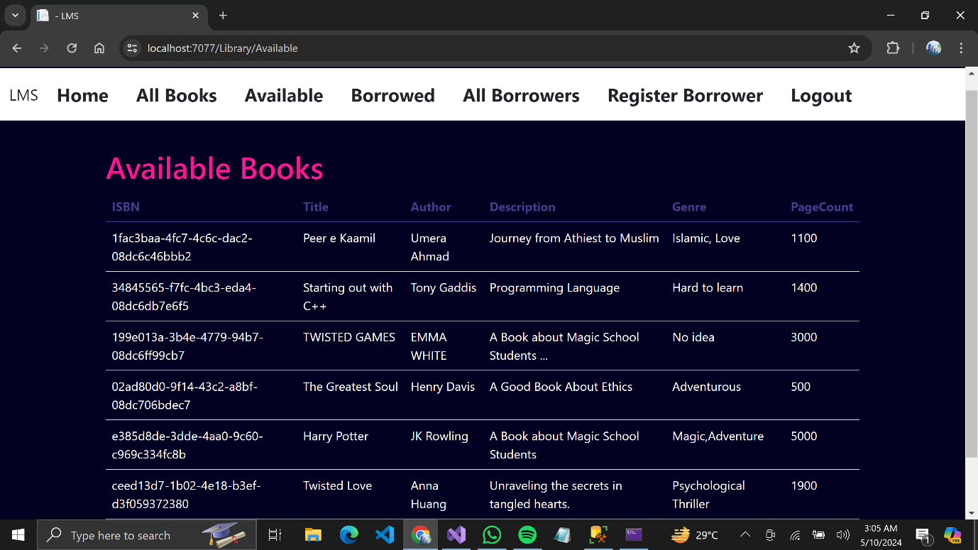

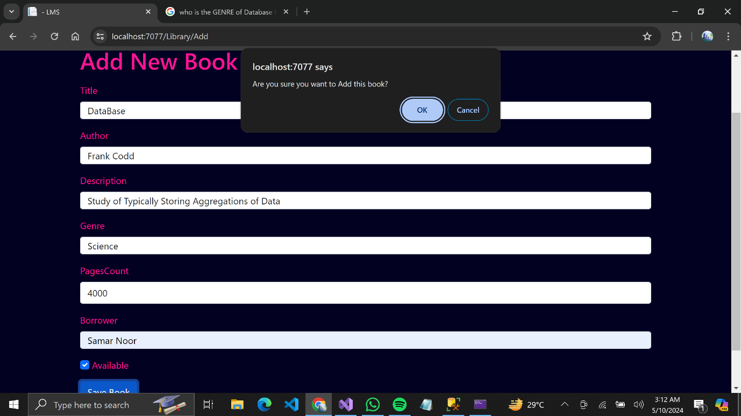

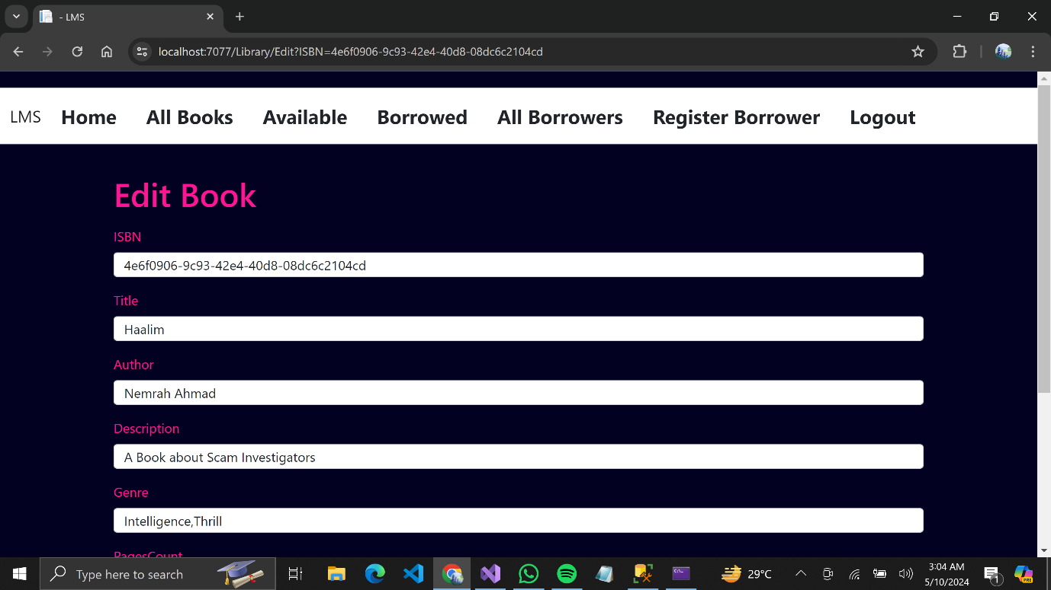

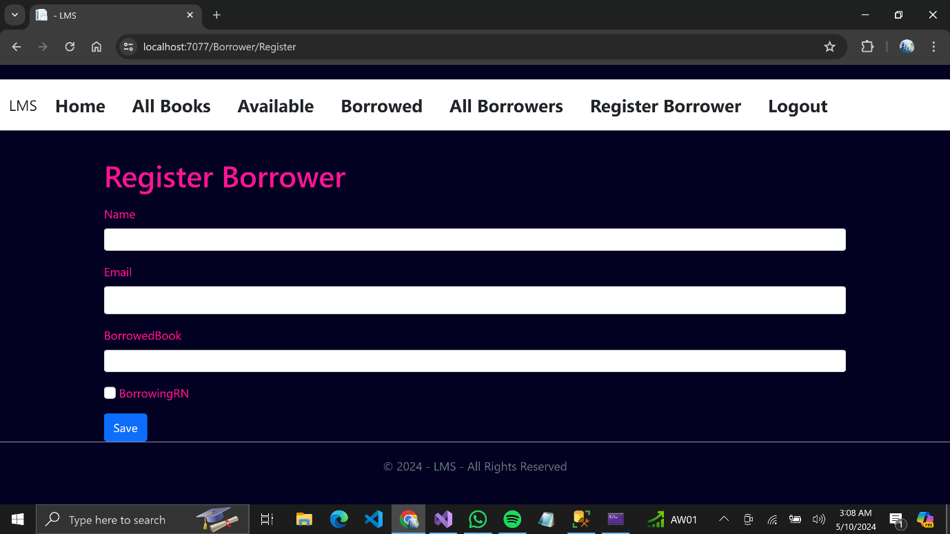

4.3 Implementation Details:

1. Technology Stack Selection:

* Chose C# with ASP.NET MVC 8.0 for frontend development and MS SQL
* Server for the backend database, based on their compatibility, robustness, and familiarity with the development team.
* Implemented frontend components using C# within the ASP.NET MVC 8.0 framework.
* Encountered challenges in designing responsive and intuitive user interfaces.
* Implemented responsive design principles to ensure compatibility across different devices and screen sizes.

1. Integration with Backend Database:

* Established connections between the frontend components and the backend MS SQL Server database.
* Faced challenges in managing data synchronization and handling database transactions.
* Overcame challenges by implementing efficient data access methods, error handling mechanisms, and transaction management techniques.

1. Authentication and Authorization:

* Implemented user authentication and authorization features to secure access to sensitive resources.
* Faced challenges in configuring authentication providers, role-based access control, and password management.
* Overcame challenges by following best practices for authentication and authorization, leveraging built-in security features of ASP.NET MVC, and conducting thorough testing of security mechanisms.

1. Testing and Debugging:

* Conducted extensive testing of the system components to identify and address bugs, errors, and performance issues.

4.4 Future Enhancements:

1. Email Notifications:

* Implement automated email notifications for overdue books, reservation pickups, and account updates to keep users informed.

1. Improved Search Functionality:

* Enhance search functionality by adding autocomplete suggestions and filters by genre, author, or publication date.

1. Visual Updates:

* Refresh the user interface with updated colors, fonts, and icons to improve visual appeal and usability.

1. Book Reviews:

* Allow users to leave reviews and ratings for books they have borrowed to help others make informed decisions.

**Conclusion:**

The library management system project successfully automated library operations, enhancing user experience and administrative efficiency. Key achievements include implementing core functionalities, intuitive interface design, and integration with MS SQL Server. Valuable lessons learned include the importance of thorough planning, effective communication, iterative development, and robust testing. Moving forward, continuous refinement and adaptation will ensure the system remains effective and relevant.

*-*-*-*-*-*-*-*-*-*